**Data Analysis Using SQL : Sales and Customer Data**

Summary:
This project focuses on analyzing sales and customer data using SQL to derive actionable insights. It involves cleaning data by removing duplicates, handling NULL values, and removing invalid records. Key analyses include customer segmentation, revenue contribution by payment methods, identifying high-value customers, and examining monthly and yearly sales trends. The findings provide a foundation for better decision-making and targeted marketing strategies.

Sales & Customer dataset : Sales Dataset Link & Customer Dataset Link

- Remove duplicate customer records.

DELETE FROM CUSTOMER_DATA
WHERE CUSTOMER_ID NOT IN (
SELECT MIN(CUSTOMER_ID)
FROM CUSTOMER_DATA
GROUP BY CUSTOMER_ID, GENDER, AGE, PAYMENT_METHOD
);

Output:
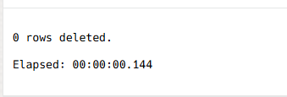

- Handle NULL values in sales and customer data.

To check for any null values.
SELECT * FROM SALES_DATA_1
WHERE PRICE IS NULL;

To update the null values with 0.
UPDATE SALES_DATA_1
SET PRICE = 0
WHERE PRICE IS NULL;

Output:

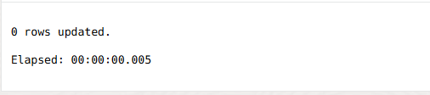

- Customer segmentation based on total spending.

WITH CustomerSpending AS (
SELECT
Customer_ID,
SUM(QUANTITY*PRICE) AS TotalSpent
FROM SALES_DATA_1
GROUP BY Customer_ID
)
SELECT
Customer_ID,
TotalSpent,
CASE
WHEN TotalSpent > 1000 THEN 'Premium'
WHEN TotalSpent BETWEEN 500 AND 1000 THEN 'Standard'
ELSE 'Basic'
END AS Segment
FROM CustomerSpending;

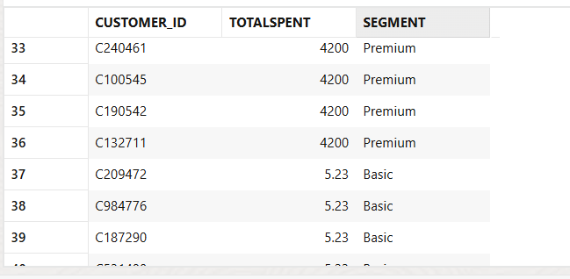
Output:

- Monthly sales trends by region.

SELECT
EXTRACT(MONTH FROM TO_DATE(INVOICE_DATE, 'DD/MM/YYYY')) AS Month,
SUM(QUANTITY * PRICE) AS MonthlySales
FROM SALES_DATA_1
GROUP BY EXTRACT(MONTH FROM TO_DATE(INVOICE_DATE, 'DD/MM/YYYY'))
ORDER BY 1;

Output:
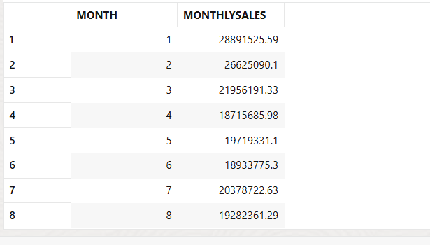

- Revenue Contribution by Payment Method.

WITH CTE1 AS
(
SELECT PAYMENT_METHOD, SUM(QUANTITY*PRICE) AS INDIVIDUALREVENUE
FROM (
SELECT SALES_DATA_1.CUSTOMER_ID, INVOICE_NO ,INVOICE_DATE, CATEGORY, QUANTITY, PRICE, SHOPPING_MALL, GENDER, AGE, PAYMENT_METHOD
FROM CUSTOMER_DATA
INNER JOIN SALES_DATA_1
ON SALES_DATA_1.CUSTOMER_ID = CUSTOMER_DATA.CUSTOMER_ID) TEMP
GROUP BY PAYMENT_METHOD),
CTE2 AS (
SELECT SUM(INDIVIDUALREVENUE) AS TOTALREVENUE
FROM CTE1)
SELECT CTE1.PAYMENT_METHOD, ROUND((CTE1.INDIVIDUALREVENUE/CTE2.TOTALREVENUE)*100, 2) AS REVENUE
FROM CTE1, CTE2;

Output:

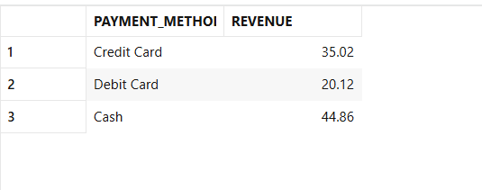

- High-value customers for targeted marketing.

SELECT
CUSTOMER_ID,
SUM(QUANTITY*PRICE) AS TotalSpending
FROM SALES_DATA_1
GROUP BY CUSTOMER_ID
HAVING SUM(QUANTITY*PRICE) > 500;

Output:

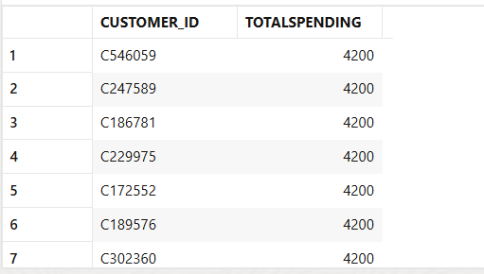

- Remove invalid sales records with negative amounts.

Find the negative sales:
SELECT * FROM
SALES_DATA_1
WHERE PRICE < 1;

If found then delete it:
DELETE FROM SALES_DATA_1
WHERE PRICE < 0;

Output:

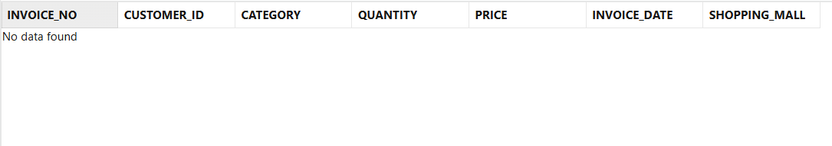

- Average spending by category.

SELECT
CATEGORY,
ROUND(AVG(QUANTITY*PRICE),2) AS AvgSpending
FROM SALES_DATA_1
GROUP BY CATEGORY
ORDER BY 2;

Output:

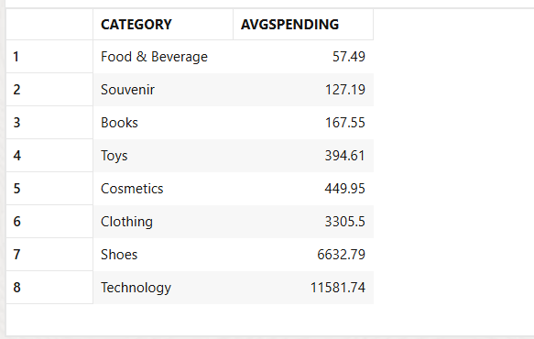

- Yearly sales trends.

SELECT
EXTRACT(YEAR FROM TO_DATE(INVOICE_DATE, 'DD/MM/YYYY')) AS Year,
SUM(QUANTITY*PRICE) AS YearlySales
FROM SALES_DATA_1
GROUP BY EXTRACT(YEAR FROM TO_DATE(INVOICE_DATE, 'DD/MM/YYYY'));

Output:

